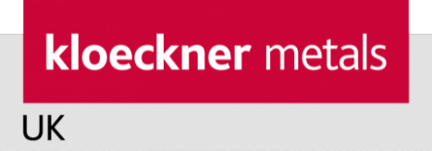

FOR RELEASE ON: Upon receipt
Contact Name: Barrie Salter
Organization: Kloeckner Metals UK
Phone Number: 0113 254 0711
Email: barrie.salter@kloeckner.com
Website: www.kloecknermetalsuk.com
Shop.kloeckner.co.uk

Twitter: @KloecknerUK
Facebook: Kloeckner Metals UK
LinkedIn: Kloeckner Metals UK

Kloeckner wins multi-million nuclear contract for Hinkley Point C

Kloeckner Metals UK is pleased to announce the award of a multi-million pound contract by BYLOR to produce embedment sleeves for the Hinkley Point C power station.

Part of the global Klöckner & Co Group, Kloeckner Metals UK is a leading multi-metals processing supplier in the UK. It has recently been certified with Fit 4 Nuclear status (F4N) which is a testament to its commitment to continuously improve operational standards in line with nuclear requirements.

This newly awarded contract will see Kloeckner Metals UK supply processed and coated embedment sleeves to Tier 1 Contractor BYLOR – a Laing O’Rourke and Bouygues TP joint venture. Two local South West businesses will assist Kloeckner Metals UK with the coating of the embedment sleeves.

Peter Whiting, CEO of Kloeckner Metals UK said: “BYLOR’s decision to select Kloeckner as their supplier is a huge endorsement for our capabilities and management expertise. We are extremely excited to be part of such an important national project.”

Kloeckner Metals UK would like to take this opportunity to thank Somerset Chamber of Commerce and SWMAS for their contribution in this project.

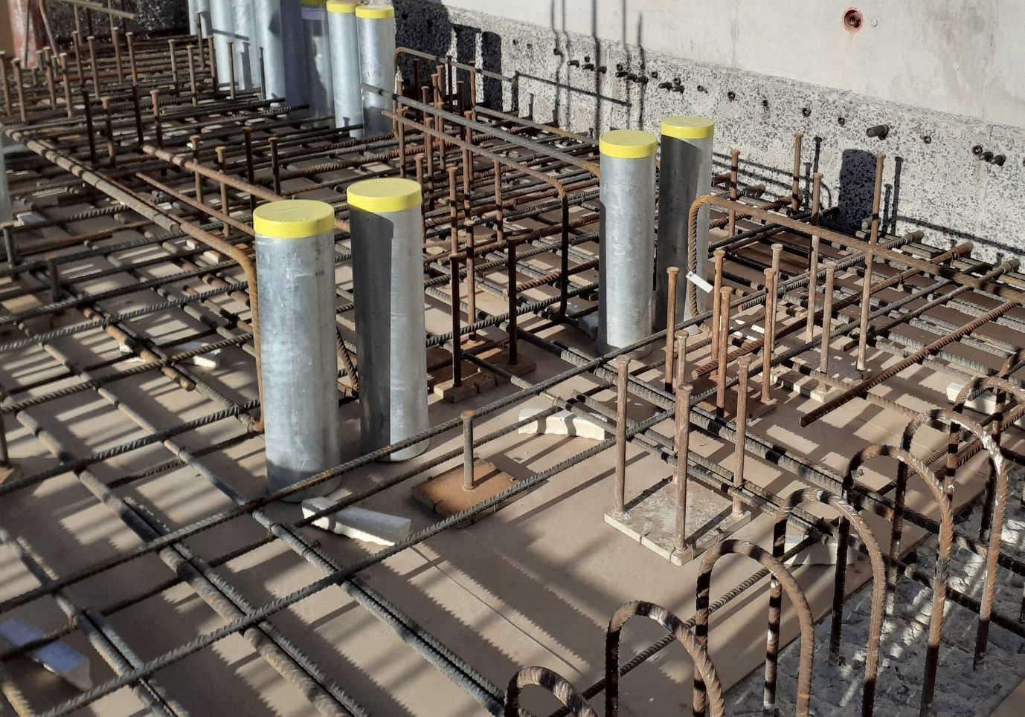

END
About Kloeckner: Kloeckner Metals UK is one of the largest mill independent multi-metal stockholders & distributors in the UK. It is a key member of the Klöckner & Co Group, one of the largest producer-independent distributors of steel and metal products and one of the leading metal distribution companies worldwide. Kloeckner Metals UK offers a diverse range of ferrous and non-ferrous products sourced from reputable and accredited mill sources in the UK and across Western Europe. In addition, Kloeckner strives to develop partnerships with clients by developing innovative value-added services and introducing digital technologies. This way clients benefit from expertise and innovation, which allows them to keep ahead of competition and develop their own business activities.

