FOR IMMEDIATE RELEASE

Nu-Tech Exhibitions + Events Celebrates 30 Years of promoting Innovation and Technology Transfer across UK industry.

(Cockermouth, 4th December 2023) - Nu-Tech Exhibitions + Events, the UK's leading and longest serving organiser of 'on-site' industrial exhibitions and specialist events, based in Cockermouth, is proud to celebrate its 30th year in business.
Established in 1993 by a senior engineering manager at Sellafield, the company was founded with the mission to promote technology transfer across UK industry, ultimately saving time and taxpayers' money.
Over the past three decades, Nu-Tech Exhibitions + Events has emerged as a leader in organising events for the nuclear, defence, maritime, aerospace, petrochemical, and science & technology sectors. Working with prestigious organisations such as the MOD, Royal Navy, AWE, DSTL, Sellafield, UKAEA, Essar Oil and EDF Energy. With a commitment to achieving results and an impressive knowledge base, the dedicated team at Nu-Tech has successfully organised numerous events throughout the UK, ranging from stakeholder engagement launch events to large-scale international conferences, as well as securing recognition with a Business Leader Award in the Chairman’s Award Scheme from BAE Systems.
"Nu-Tech Exhibitions + Events has always been at the forefront of promoting collaboration and knowledge exchange within highly regulated industry sectors," said Lisa Jones-Taylor, Managing Director of Nu-Tech. "Our 30th anniversary is a testament to the hard work and dedication of our team, as well as the trust and loyalty of our customers."
In addition to celebrating three decades of success, Nu-Tech Exhibitions + Events proudly survived the challenges posed by the COVID-19 pandemic. Despite limited support for the events industry, the company displayed resilience and adaptability, ensuring the continued success of its operations.
The company takes pride in its ability to handle events of any scale, from industrial trade exhibitions to international conferences with multiple sessions. Nu-Tech's unique approach includes installing and equipping temporary venues to ensure the success of each event.
With a loyal customer base comprising both Blue Chip companies and SMEs, Nu-Tech Exhibitions + Events has earned a reputation as the leading supplier of choice to meet the diverse needs of the UK industry. The company annually organises numerous events that attract many hundreds of satisfied customers each year.
As Nu-Tech commemorates its 30th year, the company remains committed to driving innovation, fostering collaboration, and continuing its legacy as a trailblazer in the field of industrial exhibitions.
For media enquiries, please contact:
Lisa Jones-Taylor – lisa@nu-techassoc.co.uk
01946 695554 / 01900 821508

About Nu-Tech Exhibitions + Events
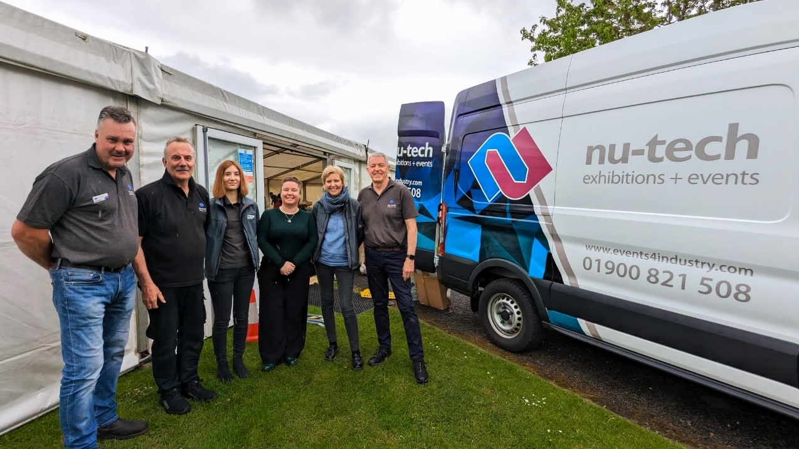
Nu-Tech Exhibitions + Events, established in 1993, is the UK's leading and longest-serving organiser of 'on-site' industrial exhibitions and specialist events. With over 30 years of experience, the company has built an impressive knowledge base and a unique ability to achieve results, making it the supplier of choice for the UK's highly regulated industry sectors.

Part of the Nu-Tech team on an event earlier this year. - Photo credit: Lianne Dempsey
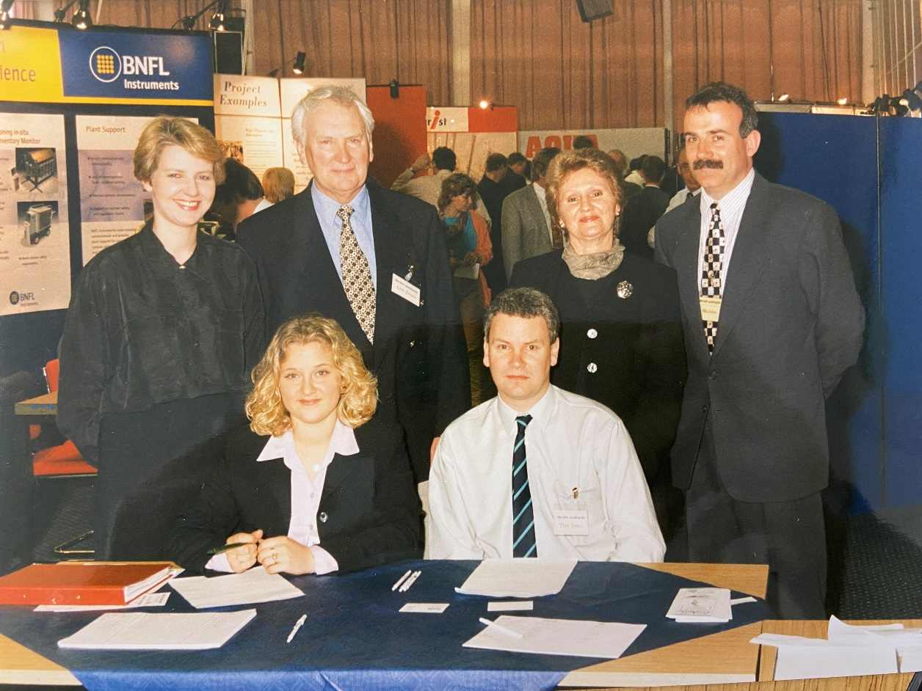

One of the Nu-Tech exhibitions at the Sellafield site c.1997

